Original: English

FTAA - COMMITTEE OF GOVERNMENT REPRESENTATIVES ON THE PARTICIPATION OF CIVIL SOCIETY

CONTRIBUTION IN RESPONSE TO THE OPEN AND ONGOING INVITATION

Name(s) | James A. Thomas
Organization(s) | ASTM International
Country | USA

Number of Pages | 4 | Language | English
Contribution covers the following country(ies) or region(s): | USA

FTAA entities (Please check the FTAA Entity(ies) addressed in the contribution)
Negotiating Group on Agriculture |  | Committee of Government Representatives on the Participation of Civil Society
Negotiating Group on Competition Policy |  | Joint Government-Private Sector Committee of Experts on Electronic Commerce
Negotiating Group on Dispute Settlement |  | Consultative Group on Smaller Economies
Negotiating Group on Government Procurement |  | Technical Committee on Institutional Issues (general and institutional aspects of the FTAA Agreement)
Negotiating Group on Intellectual Property Rights |  | FTAA Process (check if the contribution is of relevance to all the entities)
Negotiating Group on Investment
Negotiating Group on Market Access | X
Negotiating Group on Services
Negotiating Group on Subsidies, Antidumping and Countervailing Rights

EXECUTIVE SUMMARY: (2 pages maximum) must accompany any contribution with more than five pages. (Executive summaries of contributions of more than five pages as well as contributions totaling less than five pages are to be forwarded to FTAA Negotiating Groups and other Entities according to the information provided above.)

Executive Summary

ASTM International’s Comments to the Chair of the Committee Of Government Representatives on the Participation of Civil Society

ASTM International is an organization, which develops consensus standards of a global scope and use that significantly affect trade.

The current second draft agreement contains a definition for an international standardization body that limits international standards solutions and disadvantages some industry sectors in FTAA countries. Through direct reference to solely two organizations, the current definition pointedly excludes a multitude of international standardization options.

ASTM International strongly supports the U.S. Trade Representative’s position that international standardization and the relevance and fair trade aspects of the resulting standards are the result of development processes that include principles such as open and transparent procedures, consensus development among interested parties, and the inclusion of technically and globally relevant content. These principles are included in the Second Triennial Review of the Operation and Implementation of the WTO/TBT Agreement in Annex 4 of that review.

ASTM urges that the definition in the agreement chapter on Market Access, Article 12, Definitions, Page 5.92 be modified to reflect the Annex 4 principles noted above.

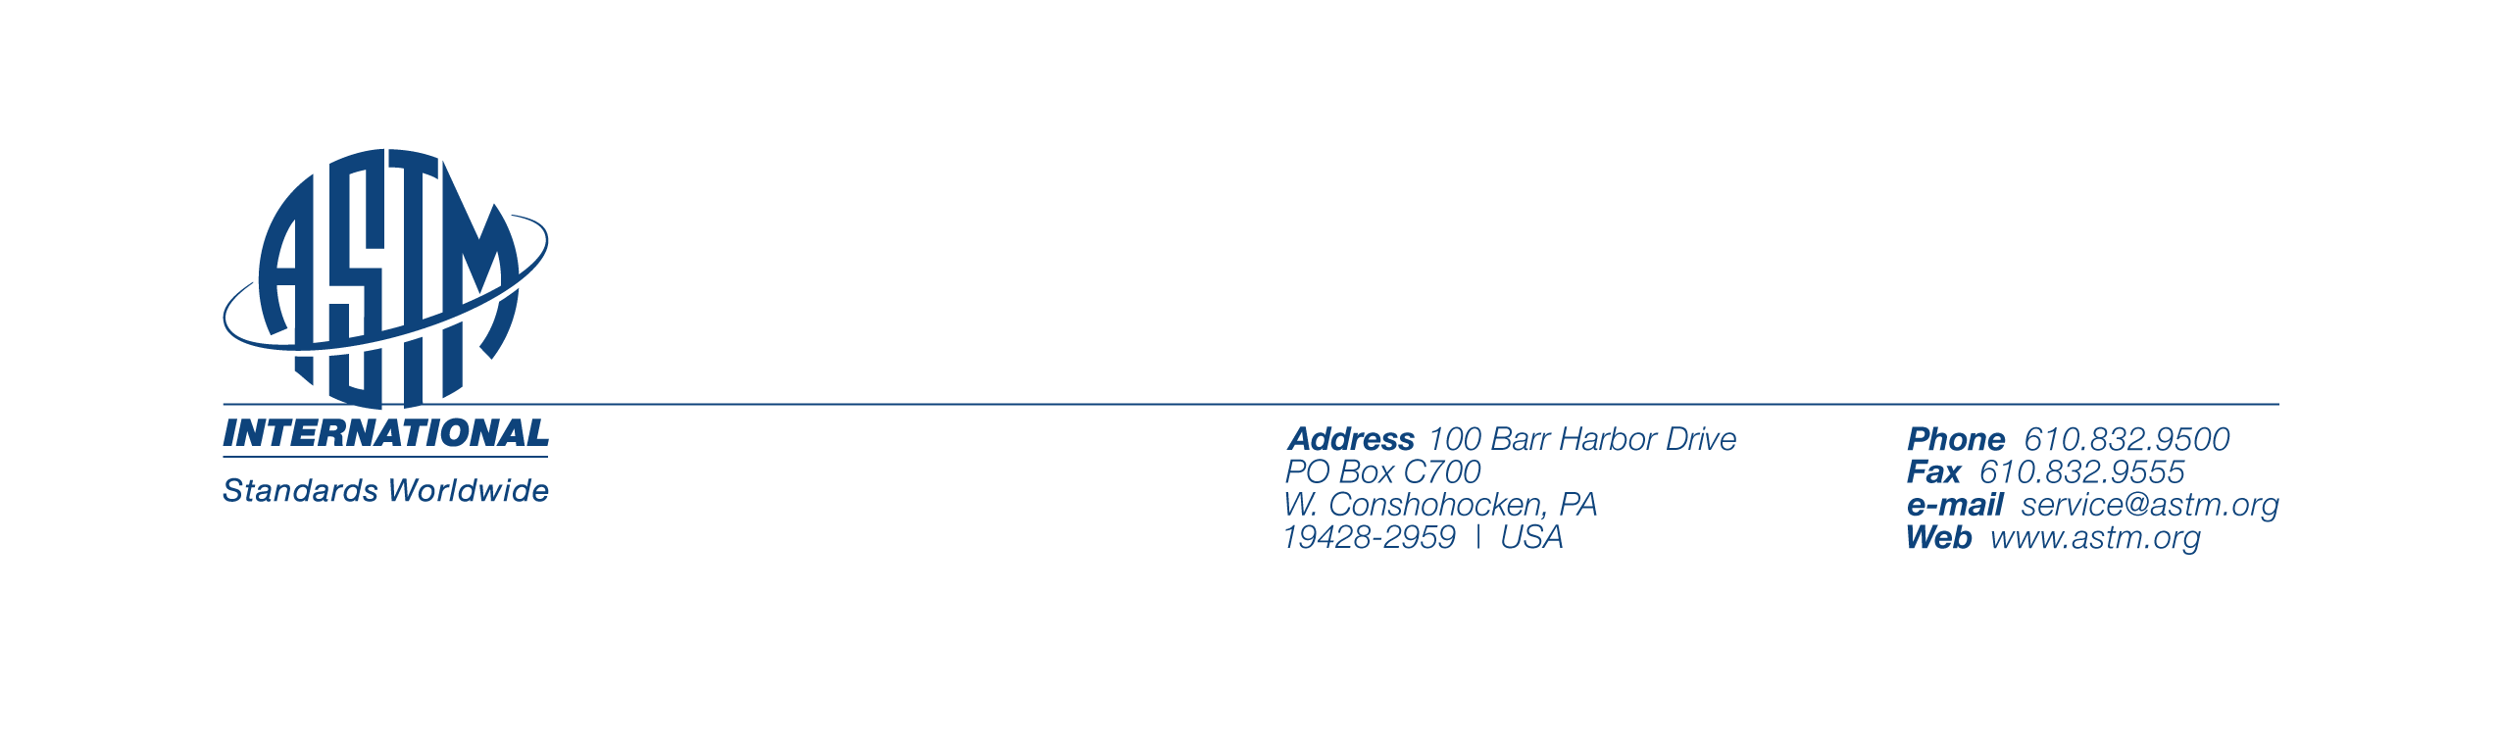
To: The Chair of the Committee of Government Representatives on the Participation of Civil Society

From: James A. Thomas, President
ASTM International
100 Barr Harbor Drive
PO Box C700
W. Conshohocken, PA 19428-2959
Tel: + 610-832-9598
E-Mail: jthomas@astm.org

Re: Second Draft FTAA Agreement
Chapter on Market Access
Article 12. Definitions
Page 5.92
Definition of International Standardization Body

ASTM International is an organization in which representatives from one hundred countries develop standards. Thousands of these standards are global in scope and use. They are developed according to principles set down by the World Trade Organization. They appear in the national portfolios and regulations of many countries around the world. Their affect on trade is significant. Their value to the economies of many FTAA countries is incalculable. There is language in the FTAA draft document however, referenced above, which effectively precludes their use and the use of standards like them.

At present, the second draft agreement definition of an international standardization body effectively limits international standards solutions and places some industry sectors in the FTAA countries at a disadvantage. The language used to define an International Standardization Body makes specific reference to two European-based, private sector voluntary standards organizations (the International Organization for Standardization [ISO] and the International Electrotechnical Commission [IEC]), pointedly excluding all others.

This definition, with its direct references to the ISO and IEC, is a virtual recommendation. It is certainly an endorsement; and it suggests that the standards that issue from these two bodies are somehow endowed with a presumption of conformity with the terms of the agreement.

It is ASTM International’s assertion that no standards body comprised of national bodies - which tend to operate as political and economic blocs - can ensure that the standards they issue will not act as barriers to trade.

But more importantly, these references taint the definition with bias and exclusivity. Implicitly, and by omission, this definition suggests that thousands of technically advanced international standards that are developed in organizations other than the ISO and IEC are either (1) not credible, (2), not international, or (3) present barriers to trade. None of these is true.

The position taken by the USTR within the WTO Committee on Technical Barriers to Trade has been that bodies which operate with open and transparent procedures and that afford an opportunity for consensus among all interested parties will result in standards which are relevant on a global basis and prevent unnecessary barriers to trade. The position of the USTR has been that the process of international standardization and the relevance and fair trade aspects of the resulting standards are related more to principles than to the structure of the institutions that produce them. ASTM International agrees wholeheartedly. These principles are articulated in the Second Triennial Review of the Operation and Implementation of the WTO/TBT Agreement in Annex 4 of that review. It is the view of ASTM International that these principles go to the heart and spirit of the TBT Agreement, and can be and should be applied to any agreement that has as its aim the elimination of technical barriers to trade, in particular the FTAA Agreement.

To that end, ASTM International proposes that the FTAA draft language in brackets be replaced by the following:

“The Parties recognize that international standards, guides or recommendations must have been elaborated following the set of principles set forth in the WTO Committee on Technical Barriers to Trade, “Decisions and Recommendations adopted by the Committee since 1 January 1995”, G/TBT/1/Rev.7, 28 November 2000, Section IX (Decision of the Committee on Principles for the Development of International Standards, Guides and Recommendations with relation to Articles 2,5, and Annex 3 of the Agreement)”, i.e., Annex 4.

