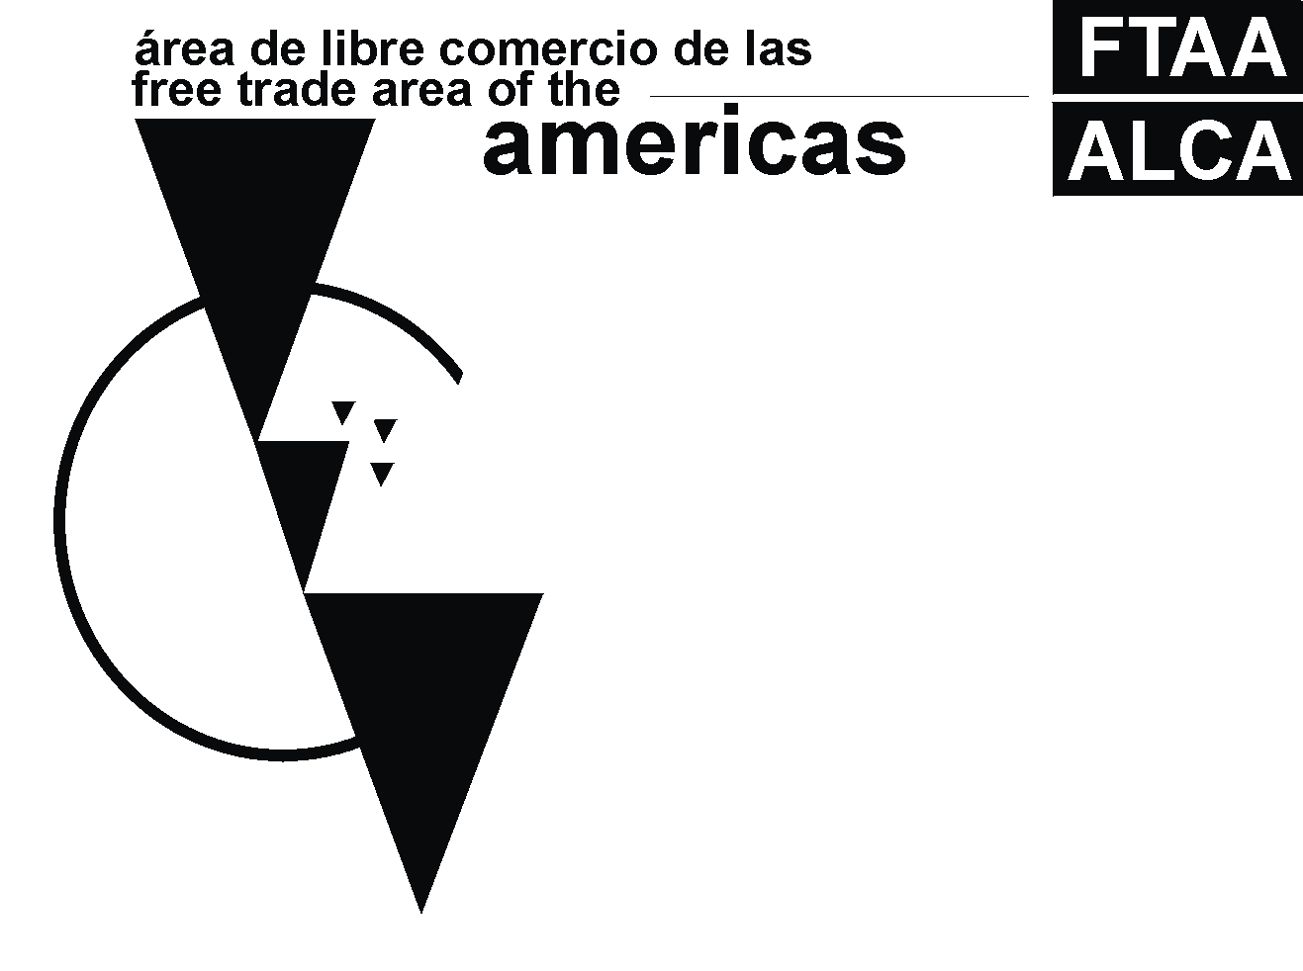

FTAA – Joint Government-Private Sector Committee of Government Representatives on Electronic Commerce

Survey on Consumer Protection

Prepared by
The United States

Original: English

FTAA - JOINT GOVERNMENT-PRIVATE SECTOR COMMITTEE OF EXPERTS ON ELECTRONIC COMMERCE

UNITED STATES

SURVEY ON CONSUMER PROTECTION

1. What national agencies are responsible for developing, monitoring and enforcing consumer protection regulations?

2. Do the agencies identified in question 1 engage in informal discussions with businesses to attempt to stop any potential violations of domestic consumer protection laws?

3. Do the agencies identified in question 1 engage in informal discussions with consumers to attempt to educate them about their rights under domestic consumer protection laws?

4. Are there efforts underway in the private sector toward self-regulatory approaches to offering consumer protections in the online environment, such as codes of conduct and/or seal programs?

5. Are there any widespread efforts on the part of the private sector to promote consumer confidence in the marketplace, such as credit card protections or other initiatives?

6. Are there any non-governmental organizations that work to promote adequate consumer protection?

7. For each agency identified in question 1, briefly describe the consumer protection statutes or regulations that the agency is responsible for enforcing. For example, do you have laws regarding:
- Fraud
- Marketing practices
- Advertising practices

8. Do these laws apply also to business conducted over the Internet?

9. Have any new regulations or laws been passed that apply to e-commerce? Is any legislation under consideration that would apply only to e-commerce?

10. How does each agency identified in question 1 enforce the statutes or regulations identified in question 6? Through consumer and business education? Through investigation of consumer complaints? Issuance of civil fines or penalties against businesses? Criminal fines or penalties? Other activities? Can these agencies take a business to court for violating consumer protection laws? If so, what relief can a court order?

11. Do the agencies identified in question 1 educate businesses and consumers about transacting online? If so, how does each agency approach this education? Do they work with NGOs?

12. Are these agencies authorized to bring law enforcement actions against a foreign business injuring your country’s consumers? Are they authorized to bring a law enforcement action against domestic businesses targeting foreign consumers? (Law enforcement actions are defined in a broad sense to include any government action that results in fines or penalties, an agreement by a company to halt fraudulent or deceptive practices, or a court or administrative order to halt fraudulent or deceptive practices.) Does your legal systems allow for consumer class action suits?

