Original: English

FTAA - COMMITTEE OF GOVERNMENT REPRESENTATIVES ON THE PARTICIPATION OF CIVIL SOCIETY

CONTRIBUTION IN RESPONSE TO THE OPEN AND ONGOING INVITATION

Name(s) | Alexandra Spieldoch, Maria Riley
Organization(s) | Center of Concern, International Gender and Trade Network
Country | USA

Number of Pages | 4 | Language | English
Contribution covers the following country(ies) or region(s): | The entire regional process

FTAA entities (Please check the FTAA Entity(ies) addressed in the contribution)
Negotiating Group on Agriculture |  | Committee of Government Representatives on the Participation of Civil Society | X
Negotiating Group on Competition Policy |  | Joint Government-Private Sector Committee of Experts on Electronic Commerce
Negotiating Group on Dispute Settlement |  | Consultative Group on Smaller Economies
Negotiating Group on Government Procurement |  | Technical Committee on Institutional Issues (general and institutional aspects of the FTAA Agreement)
Negotiating Group on Intellectual Property Rights |  | FTAA Process (check if the contribution is of relevance to all the entities) | X
Negotiating Group on Investment
Negotiating Group on Market Access
Negotiating Group on Services
Negotiating Group on Subsidies, Antidumping and Countervailing Rights
EXECUTIVE SUMMARY: (2 pages maximum) must accompany any contribution with more than five pages. (Executive summaries of contributions of more than five pages as well as contributions totaling less than five pages are to be forwarded to FTAA Negotiating Groups and other Entities according to the information provided above.)

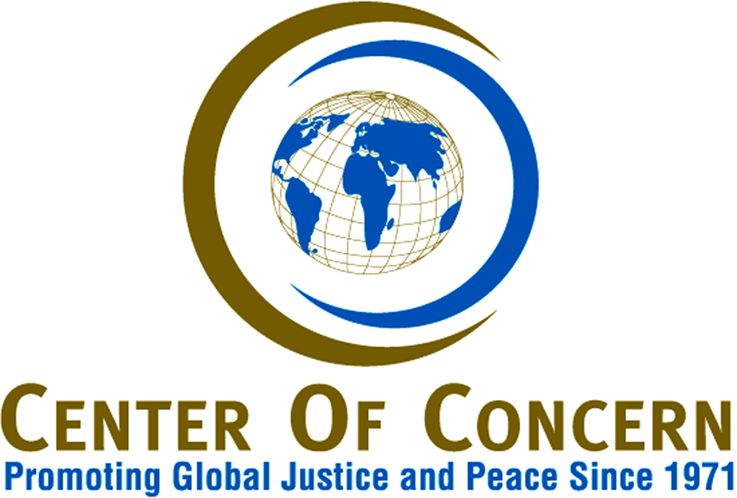

May 1, 2003

Chair of the Committee of Government Representatives on the
Participation of Civil Society (Civil Society Committee)
Secretaria del Area de Libre Comercio de Las Americas
8 Oriente N 1006
Paseo San Francisco
Centro Historico, Puebla 72000
Mexico

To the Civil Society Committee:

Thank you for the opportunity to submit our contribution to this Committee of Government Representatives on the Participation of Civil Society in the Free Trade Area of the Americas process.

The Center of Concern is a Washington, D.C., faith-based non-governmental organization which promotes social analysis, theological reflection, policy advocacy, and public education on issues of global development, domestic/global links, and just international policies on finance and trade. The Center has consultative status with ECOSOC at the United Nations and has been accredited to WTO Ministerials in Singapore, Geneva, Seattle and Doha. We are in the process of seeking accredition for the upcoming Ministerial in Cancun.

The Center also houses the Secretariat for the International Gender and Trade Network which includes seven regional networks: Africa, Asia, Caribbean, Europe, North America, Latin America, and the Pacific. Our particular contribution to the dialogue on trade is an emphasis on equity and development which arises from a gender-sensitive analysis of the effects of trade and other macro-economic policies on social development and on women’s, families’ and communities’ well-being. In this context, equity is not only gender equity but also racial and ethnic equity and equity among nations.

The Center has been monitoring the FTAA negotiations, in so far as possible, and is a member of the Hemispheric Social Alliance (HSA) - which, as you probably know by now, has boycotted this committee due to its inability to ensure a democratic process within the FTAA negotiations. We write to you in support of the HSA’s position and include a short explanation of why we are boycotting this Committee’s invitation for substantive comments at this time:

Lack of Transparency

The Center has consistently called for a more transparent FTAA process that makes information available in a timely, relevant fashion and allows for civil society to know exactly how the FTAA negotiations are developing. If this Committee can claim any success, it is within this category of transparency. For example, it is a positive step that this Committee lobbied for the release of the draft FTAA texts and that both draft texts have been released. Unfortunately, the texts were released after negotiators had already convened the Ministerials. Civil society groups were never given the chance to reply to the specifics of the texts as part of the negotiating process. The two draft texts are heavily bracketed, making it impossible to identify key government negotiating positions. Civil society groups are left guessing what most of the FTAA governments, including the U.S., are proposing. We have contributed in the analysis of the released texts (which have been sent to you by the Alliance for Responsible Trade) and can state from experience that we are still left wondering what are the real dynamics of the negotiations.

It is also a positive step towards transparency that the Civil Society Committee reports are now posted on the official FTAA web site. These reports are helpful in showing that at least someone is reading the submissions and that they are somehow documented in the official process. However, these reports are benign in that they do not contribute to any shift in the negotiations of the FTAA.

Although strides have clearly been made, they are but small gestures that do not ensure full transparency in the negotiations. Civil society groups are still scrambling to receive information after the fact, which is counter to a democratic process.

Lack of Accountability

Perhaps the biggest problem with the FTAA negotiations has always been the lack of accountability to millions of people throughout the Americas whose governments are negotiating policies which will impact their lives on many levels and yet their advocacy and analysis (particularly when they are dealing with social and environmental concerns) are considered secondary to the official negotiating process.

Your report states that civil society submissions will be forwarded to FTAA negotiators on a regular basis and that they will also be forwarded to trade ministers in preparation for the Miami Ministerial in November, 2003. The reality is that this process has not worked to date. It continues to be a one-way dialogue in which many civil society groups spend hours putting our advocacy positions and analysis on official paper that never sparks any meaningful dialogue on the different critiques of the FTAA in the different sectoral areas.

The Civil Society Committee report, November 2002, states that guidelines were drafted to hold five regional seminars with the support of the Tripartite Committee (pending funding). The report highlights the regional seminar that took place in Merida, Mexico for North America as an accomplishment towards increased communication with civil society. The Center of Concern has consistently advocated for public meetings to take place both in the U.S. and regionally and welcomes meaningful dialogue as a major step towards accountability within the FTAA. Unfortunately, these regional seminars are organized as public relations events and not substantive debates. Visibility and accountability do not mean the same thing.

Lack of Participation

We commend the Civil Society Committee for inviting the FTAA countries to extend ‘necessary courtesies’ toward civil society groups who plan to hold parallel fora to the Ministerials and Vice Ministerials. The reality is that civil society groups will continue to organize parallel fora with or without these ‘necessary courtesies.’ The issues at stake are too important to be left solely at the hands of this Committee and the trade negotiators.

The Center of Concern and other organizations have repeatedly requested that civil society groups be allowed to participate in the FTAA Ministerials with consultative status (as has been instituted at the United Nations). No where in the most recent Civil Society Committee report does it mention any move to push negotiators on this issue. The bottom line, then, is that the Ministerials continue to be closed political spaces that are not participatory, transparent or accountable.

Based on these three major themes, we reject the notion that this Committee has been an effective avenue for communication and democratic processes to date. This Committee has no teeth and can do very little to effect the official negotiations. It is used as a smoke screen and a clearinghouse of information that will eventually get to the negotiators who will not be held accountable to respond. This is scandalous and yet the Civil Society Committee does not have the capacity to address this within the FTAA.

We have chosen to respond to the request for submissions to remind this Committee and the U.S.Government that we have sent our positions to both entities with no meaningful response to date. We continue to advocate for another model of integration that is equitable, fair, socially sustainable and democratic at its core. We implore the FTAA negotiators, including this Civil Society Committee and U.S. Government, to post this official critique on the FTAA web site and to forward it to the negotiating groups so that we can begin to work towards this goal.

Sincerely,

Alexandra Spieldoch Maria Riley
Senior Program Associate Program Director

CC’d to:

Christina R. Sevilla, U.S. Lead, FTAA Civil Society Committee
Ross Wilson, Senior Negotiator for the Free Trade Area of the Americas
Christopher A. Pedilla, Intergovernmental Affairs and Public Liaison

