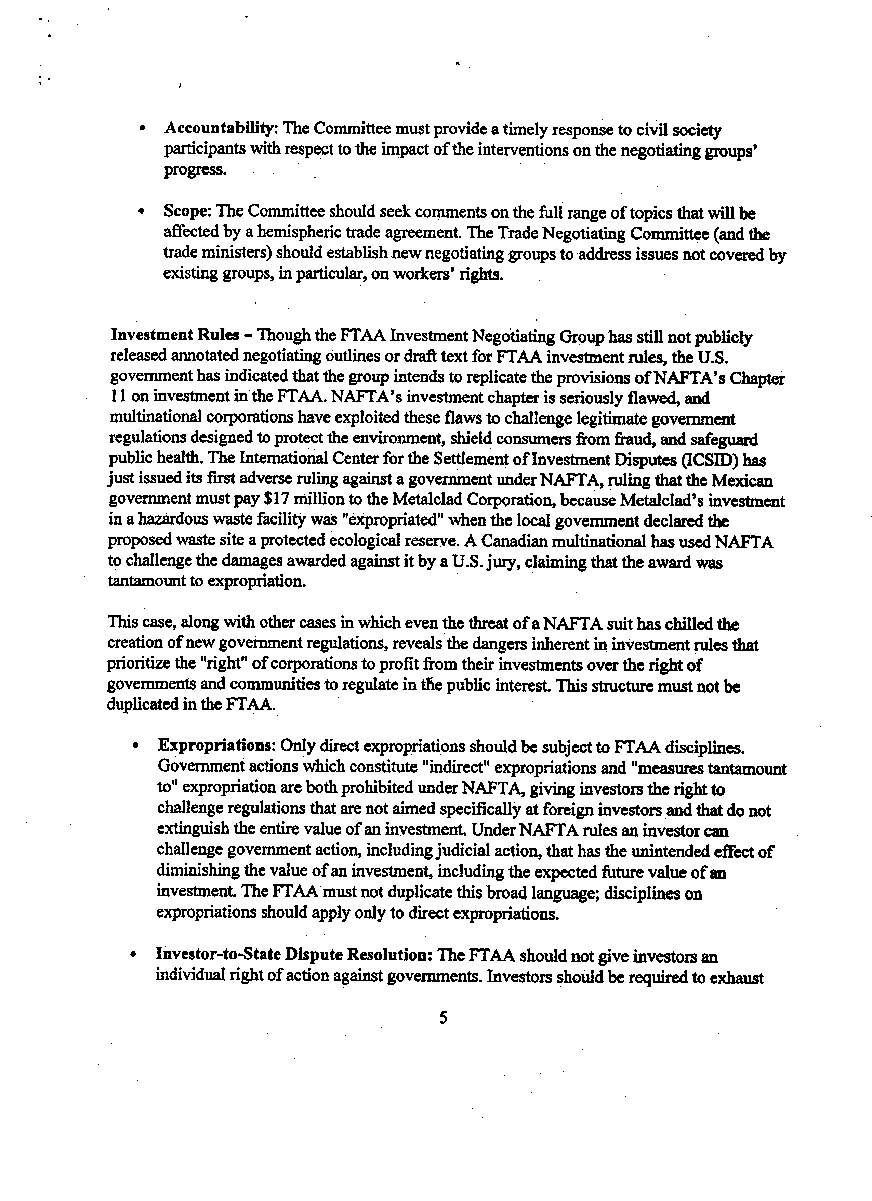
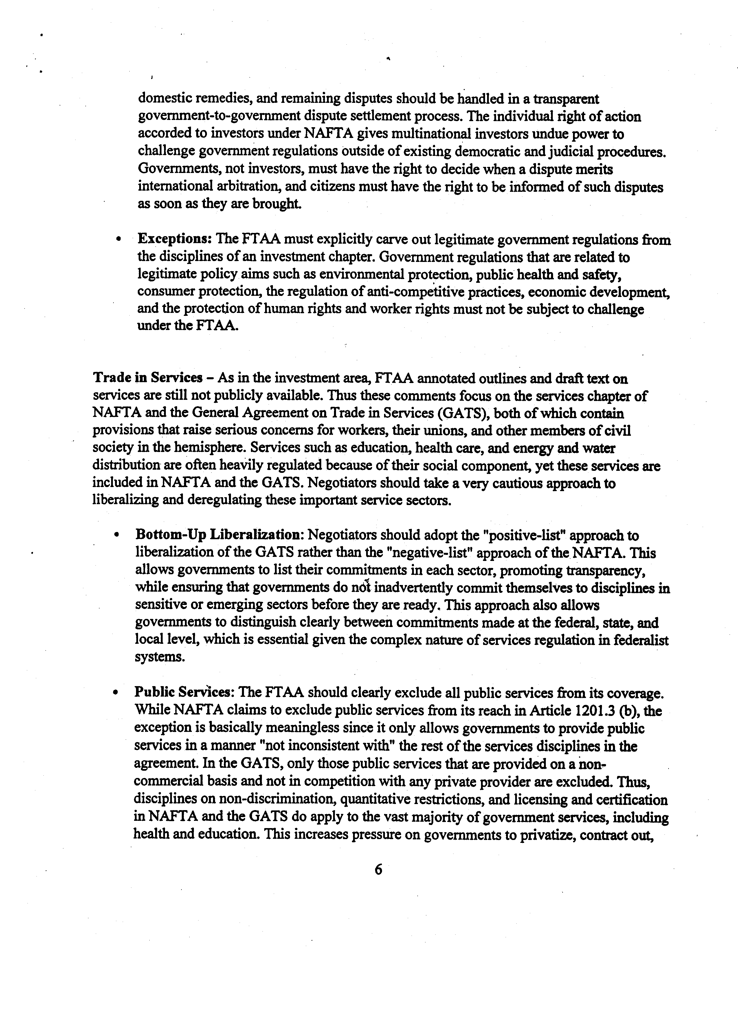
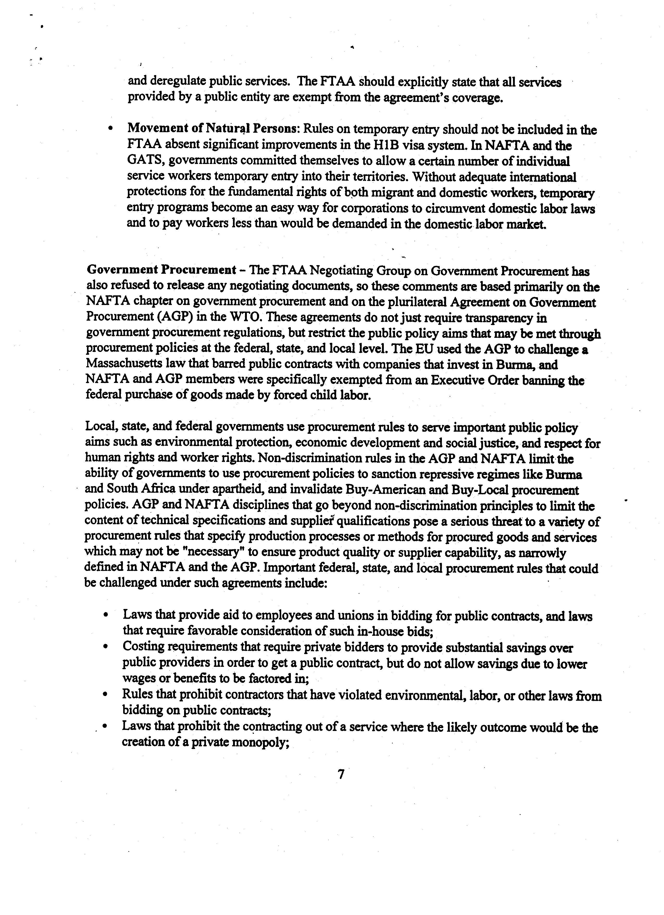
I
.Regulations that favor the procurement of goods that contain a certain percentage of recycled material or have other environmental value;
.Living wage laws and laws that bar the procurement of goods made under sweatshop conditions; and .
.Affirmative action preferences and preferences for goods and services produced in disadvantaged local communities.
FT AA disciplines on government procurement must clearly exempt from their coverage the
above procurement rules and any other procurement rules that are related to important policy goals such as environmental protection, public health and safety , consumer protection, the
regulation of anti-competitive practices, economic development, and the protection ofhuman rights and worker rights. All FT AA procurement rules must. be carefully scrutinized for any
additional adverse impacts they may have on legitimate social policy objectives. Unfortunately, public scrutiny of these rules cannot take place until the negotiating texts are made public.
Intellectual Property Rights -Both NAFT A and the WTO agreement on Trade-Related
Aspects of Intellectual Property Rights (TRIPs) contain substantial provisions guaranteeing the international protection of copyrights, trademarks and patents. Intellectual property should be
protected to the extent to which such protection stimulates and rewards innovation and creativity , thus benefitting the society as a whole. But intellectual property rules must also recognize that there is a limit to the exclusive rights of an individual patent holder when public health and safety are at stake.
.Life-Saving Pharmaceuticals: FT AA rules should give governments sufficient authority to compel the licensing of life-saving pharmaceuticals in a public health crisis. TRIPs and NAFrA both allow compulsory licensing in the case of national emergencies. This exception should be spelled out in the FT AA to ensure that public health crises are
considered national emergencies within the agreement, and to ensure that governments
who use this exception will not be subject to sanctions under the FT AA or any other trade law. Negotiators should also consider the public health benefits of parallel importing and of national laws in the hemisphere which prohibit the patenting of pharmaceuticals altogether.
.Patenting of Life Forms: The U.S. already allows genetically engineered life forms to be patented, but there is growing concern domestically and internationally over the ethical, environmental, and health consequences of such patents. U.S. law also allows
technological processes relating to the use of life forms (engineered or not) to be
patented, but some indigenous groups and peasant farmers have found it difficult to use their native seeds and plants once the processes for use are owned by a multinational corporation.
FT AA n~gotiators can best ensure that the social consequences of international intellectual
Ii~.:' -~', 8 ' ..c"

.

property protection are taken into account If the negotiation process is made public and if civil society groups are engaged in a true dialogue with negotiators throughout the FT AA process. Workers and trade unionists are ~ager to play an active role in this dialogue.
In conclusion, we hope that the COR and the FT AA negotiating process will give due weight to the issues raised here. In our view, the success or failure of the FT AA will hinge on governments' willingness and ability to craft an economic integration agreement that appropriately addresses the social dimension of trade and investment, as well as commercial elements. We look forward to a productive and constructive dialogue.
9

