Original: English - Spanish
Translation: non FTAA Secretariat
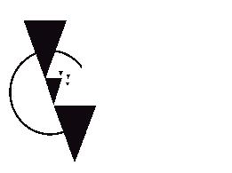

FTAA – Free Trade Area of the Americas

Third Draft Agreement

